

**University of Westminster**

**Informatics Institute of Technology**

**Advance Client-side Development**

**5COSC026C.1**

**Personal Portfolio**

**Name : Gayathri Nethmini Abeysekara**

**IIT ID : 20221997**

**UOW ID : w2053775**

**Tutorial group : G16**

Contents

Table of Figures 2

1. Screenshots 3

2. Code 5

2.1 Home page 5

2.2 About Page 7

2.3 Services Page 10

2.4 Contact Page 11

2.5 Blog Post page 19

2.6 CSS code for Home , about and services pages 25

3. Diary 33

# Table of Figures

Figure 1 : Home Page 3

Figure 2 : About Page 3

Figure 3 : Services Page 4

Figure 4 : Contact Page 4

# Screenshots

# 

Figure 1 : Home Page

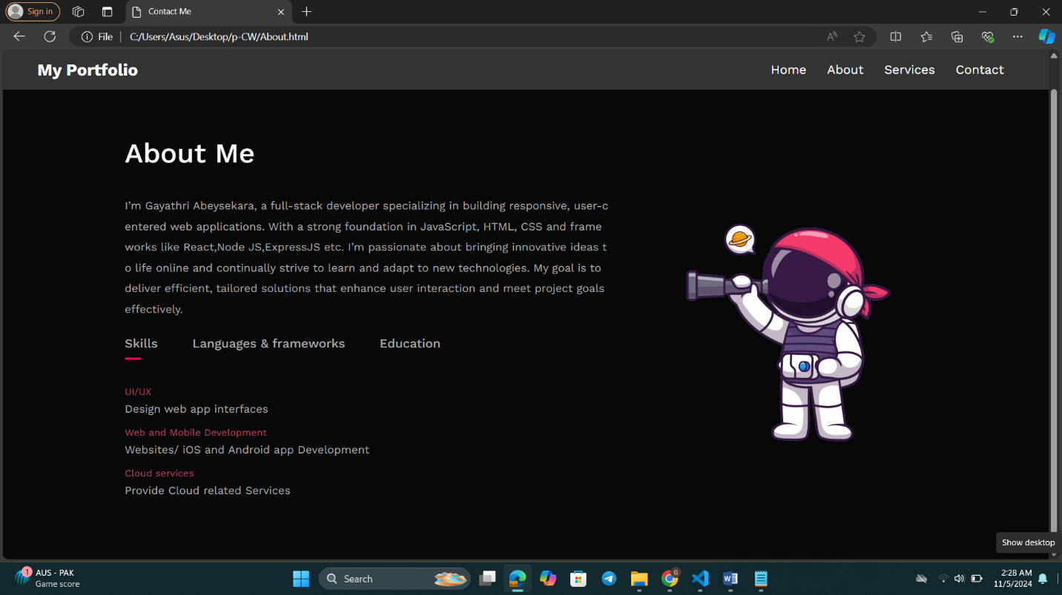

Figure 2 : About Page

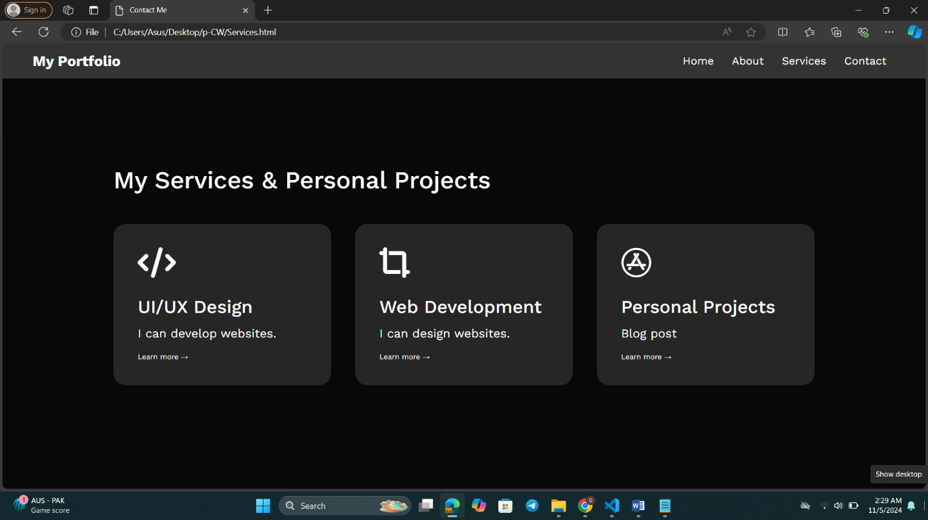

Figure 3 : Services Page

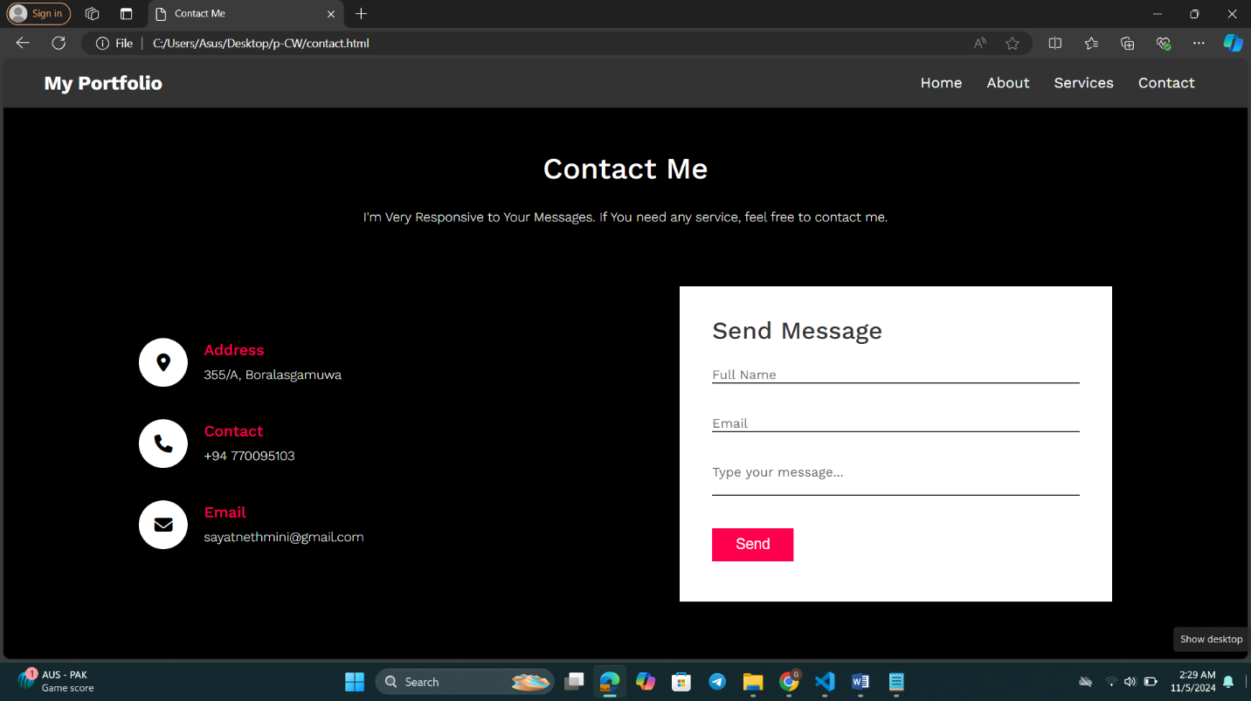

Figure 4 : Contact Page

# Code

## 2.1 Home page

<!DOCTYPE html>

<html>

  <head>

    <meta charset="UTF-8" />

    <meta http-equiv="X-UA-Compatible" content="IE=edge" />

    <meta name="viewport" content="width=device-width, initial-scale=1.0" />

    <title>Personal Portfolio Website</title>

    <link rel="stylesheet" href="portfolioCW.css" />

    <script

      src="https://kit.fontawesome.com/23df9ec51a.js"

      crossorigin="anonymous"

    ></script>

    <style>

@import url('https://fonts.googleapis.com/css2?family=Nunito:ital,wght@0,200..1000;1,200..1000&family=Playwrite+GB+S:ital,wght@0,100..400;1,100..400&family=Poppins:ital,wght@0,100;0,200;0,300;0,400;0,500;0,600;0,700;0,800;0,900;1,100;1,200;1,300;1,400;1,500;1,600;1,700;1,800;1,900&family=Work+Sans:ital,wght@0,100..900;1,100..900&display=swap');

</style>

  </head>

  <body>

*<!-- navigation bar -->*

    <container>

    <header class="navbar">

      <div class="logo">My Portfolio</div>

      <ul>

        <li><a href="Home.html">Home</a></li>

        <li><a href="About.html">About</a></li>

        <li><a href="Services.html">Services</a></li>

        <li><a href="contact.html">Contact</a></li>

      </ul>

      <i class="fas fa-bars menu-toggle" onclick="toggleMenu()"></i>

    </header>

    <br>

    <div class="container">

        <div class="row">

          <div class="col-2">

            <p>Full Stack Developer</p>

            <h1>

              Hi, I am <span>Gayathri</span><br />

              Abeysekara.

            </h1>

*<!--Button container-->*

            <div class="button-container">

              <a href="CV.pdf" download ="CV.pdf" class="btn btn2">Download CV</a>

*<!-- Linked social icons -->*

            <div class="social-icons">

              <a href="https://www.facebook.com/Gayathri-Abeysekara" target="_blank" rel="noopener noreferrer">

                <i class="fa-brands fa-facebook"></i

              ></a>

              <a href="https://www.instagram.com/its.gaya_thri/"><i class="fa-brands fa-instagram"></i></a>

              <a href="https://www.linkedin.com/in/gayathri-abeysekara-540344266/"><i class="fa-brands fa-linkedin"></i></a>

            </div>

            </div>

          </div>

*<!-- Personal Image -->*

          <div class="col-1">

            <img src="images/img10.png">

          </div>

        </div>

      </div>

    </div>

  </body>

</html>

## 2.2 About Page

<!DOCTYPE html>

<html lang="en">

  <head>

    <meta charset="UTF-8" />

    <meta name="viewport" content="width=device-width, initial-scale=1.0" />

    <title>Contact Me</title>

    <script

      src="https://kit.fontawesome.com/23df9ec51a.js"

      crossorigin="anonymous"

    ></script>

    <link rel="stylesheet" href="portfolioCW.css" />

    <style>

      @import url("https://fonts.googleapis.com/css2?family=Nunito:ital,wght@0,200..1000;1,200..1000&family=Playwrite+GB+S:ital,wght@0,100..400;1,100..400&family=Poppins:ital,wght@0,100;0,200;0,300;0,400;0,500;0,600;0,700;0,800;0,900;1,100;1,200;1,300;1,400;1,500;1,600;1,700;1,800;1,900&family=Work+Sans:ital,wght@0,100..900;1,100..900&display=swap");

    </style>

  </head>

  <body>

*<!-- Navbar -->*

    <header class="navbar">

      <div class="logo">My Portfolio</div>

      <ul>

        <li><a href="Home.html">Home</a></li>

        <li><a href="About.html">About</a></li>

        <li><a href="Services.html">Services</a></li>

        <li><a href="contact.html">Contact</a></li>

      </ul>

      <i class="fas fa-bars menu-toggle" onclick="toggleMenu()"></i>

    </header>

    <br /><br />

*<!-- About section -->*

    <div class="container">

      <div id="about">

        <div class="row1">

          <div class="about-col-2">

            <h1 class="sub-title">About Me</h1>

            <br /><br />

            <p>

              I’m Gayathri Abeysekara, a full-stack developer specializing in

              building responsive, user-centered web applications. With a strong

              foundation in JavaScript, HTML, CSS and frameworks like React,Node

              JS,ExpressJS etc. I’m passionate about bringing innovative ideas

              to life online and continually strive to learn and adapt to new

              technologies. My goal is to deliver efficient, tailored solutions

              that enhance user interaction and meet project goals effectively.

            </p>

            <div class="tab-titles">

              <p class="tab-links active-link" onclick="opentab('skills')">

                Skills

              </p>

              <p class="tab-links" onclick="opentab('experiance')">

                Languages & frameworks

              </p>

              <p class="tab-links" onclick="opentab('education')">Education</p>

            </div>

            <div class="tab-contents active-tab" id="skills">

              <ul>

                <li><span>UI/UX</span><br />Design web app interfaces</li>

                <li>

                  <span>Web and Mobile Development</span><br />Websites/ iOS and

                  Android app Development

                </li>

                <li>

                  <span>Cloud services</span><br />Provide Cloud related

                  Services

                </li>

              </ul>

            </div>

            <div class="tab-contents" id="experiance">

              <ul>

                <li><span>Frontend</span><br />React, Angular, NextJs</li>

                <li><span>Backend</span><br />EXpressJS , SpringBoot</li>

                <li><span>Version Control tools</span><br />Git , github</li>

              </ul>

            </div>

            <div class="tab-contents" id="education">

              <ul>

                <li>

                  <span>2022</span><br />Advanced Certificate in Higher

                  Education at IIT (University of Westminster)

                </li>

                <li>

                  <span>2020-2026</span><br />Bachelor's degree in Computer

                  Science at University of Westminster UK

                </li>

                <li><span>2024</span><br />Web Development at AATC</li>

              </ul>

            </div>

          </div>

*<!-- image -->*

          <div class="about-col-1">

            <img class="img" src="images/astonunt.png" />

          </div>

        </div>

      </div>

    </div>

*<!-- JavaScript for the website -->*

    <script>

      var tablinks = document.getElementsByClassName("tab-links");

      var tabcontents = document.getElementsByClassName("tab-contents");

      function opentab(*tabname*) {

        for (let tablink of tablinks) {

          tablink.classList.remove("active-link");

        }

        for (let tabcontent of tabcontents) {

          tabcontent.classList.remove("active-tab");

        }

*// Add active classes to the clicked tab link and the corresponding tab content*

        event.currentTarget.classList.add("active-link");

        document.getElementById(*tabname*).classList.add("active-tab");

      }

    </script>

  </body>

</html>

## 2.3 Services Page

<!DOCTYPE html>

<html lang="en">

  <head>

    <meta charset="UTF-8" />

    <meta name="viewport" content="width=device-width, initial-scale=1.0" />

    <title>Contact Me</title>

    <script

      src="https://kit.fontawesome.com/23df9ec51a.js"

      crossorigin="anonymous"

    ></script>

    <link rel="stylesheet" href="portfolioCW.css" />

    <style>

      @import url("https://fonts.googleapis.com/css2?family=Nunito:ital,wght@0,200..1000;1,200..1000&family=Playwrite+GB+S:ital,wght@0,100..400;1,100..400&family=Poppins:ital,wght@0,100;0,200;0,300;0,400;0,500;0,600;0,700;0,800;0,900;1,100;1,200;1,300;1,400;1,500;1,600;1,700;1,800;1,900&family=Work+Sans:ital,wght@0,100..900;1,100..900&display=swap");

    </style>

  </head>

  <body>

*<!-- Navbar -->*

    <header class="navbar">

      <div class="logo">My Portfolio</div>

      <ul>

        <li><a href="Home.html">Home</a></li>

        <li><a href="About.html">About</a></li>

        <li><a href="Services.html">Services</a></li>

        <li><a href="contact.html">Contact</a></li>

      </ul>

      <i class="fas fa-bars menu-toggle" onclick="toggleMenu()"></i>

    </header>

    <br /><br /><br />

    <br /><br /><br />

    <br /><br /><br />

*<!-- Services Section -->*

    <div id="services">

      <div class="container">

        <h1 class="sub-title">My Services & Personal Projects</h1>

        <div class="services-list">

          <div>

            <i class="fa-solid fa-code"></i>

            <h2>UI/UX Design</h2>

            <p>I can develop websites.</p>

            <a class="learnmore" href="uiUX.html">Learn more</a>

          </div>

          <div>

            <i class="fa-sharp fa-solid fa-crop-simple"></i>

            <h2>Web Development</h2>

            <p>I can design websites.</p>

            <a

              class="learnmore"

              href="https://github.com/nethminiabeysekara/Aquatic"

              >Learn more</a

            >

          </div>

          <div>

            <i class="fa-brands fa-app-store"></i>

            <h2>Personal Projects</h2>

            <p>Blog post</p>

            <a class="learnmore" href="blog post1.html">Learn more</a>

          </div>

        </div>

      </div>

    </div>

  </body>

</html>

## 2.4 Contact Page

<!DOCTYPE html>

<html lang="en">

  <head>

    <meta charset="UTF-8" />

    <meta name="viewport" content="width=device-width, initial-scale=1.0" />

    <title>Contact Me</title>

    <script

      src="https://kit.fontawesome.com/23df9ec51a.js"

      crossorigin="anonymous"

    ></script>

    <link

      href="https://fonts.googleapis.com/css2?family=Nunito:ital,wght@0,200..1000;1,200..1000&family=Playwrite+GB+S:ital,wght@0,100..400;1,100..400&family=Poppins:ital,wght@0,100;0,200;0,300;0,400;0,500;0,600;0,700;0,800;0,900;1,100;1,200;1,300;1,400;1,500;1,600;1,700;1,800;1,900&family=Work+Sans:ital,wght@0,100..900;1,100..900&display=swap"

      rel="stylesheet"

    />

    <style>

      * {

        margin: 0;

        padding: 0;

        box-sizing: border-box;

      }

      body {

        width: 100%;

        height: 100%;

        overflow-x: hidden;

        line-height: 30px;

        font-family: "Work Sans", sans-serif;

        font-optical-sizing: auto;

        font-style: normal;

      }

*/* Navigation Bar */*

      .navbar {

        width: 100%;

        background-color: #333;

        display: flex;

        justify-content: space-between;

        align-items: center;

        padding: 15px 50px;

        position: fixed;

        top: 0;

        z-index: 1000;

      }

      .navbar .logo {

        color: #fff;

        font-size: 24px;

        font-weight: bold;

      }

      .navbar ul {

        list-style: none;

        display: flex;

      }

      .navbar ul li {

        margin: 0 15px;

      }

      .navbar ul li a {

        color: #fff;

        text-decoration: none;

        font-size: 18px;

        transition: color 0.3s;

      }

      .navbar ul li a:hover {

        color: #ff004f;

      }

*/* Responsive Navigation */*

      .navbar .menu-toggle {

        display: none;

        font-size: 24px;

        color: #fff;

      }

      @media (max-width: 768px) {

        .navbar ul {

          display: none;

          flex-direction: column;

          background-color: #333;

          width: 100%;

        }

        .navbar ul.active {

          display: flex;

        }

        .navbar .menu-toggle {

          display: block;

          cursor: pointer;

        }

      }

*/* Main Content */*

      .contact {

        position: relative;

        min-height: 100vh;

        padding: 100px 100px 50px; */* Adjusted for navbar */*

        display: flex;

        justify-content: center;

        align-items: center;

        flex-direction: column;

        background-color: black;

        background-size: cover;

      }

      .contact .content {

        max-width: 800px;

        text-align: center;

      }

      .contact .content h2 {

        font-size: 36px;

        font-weight: 500;

        color: #fff;

      }

      .contact .content p {

        font-weight: 300;

        color: #fff;

      }

      .container {

        width: 100%;

        display: flex;

        justify-content: center;

        align-items: center;

        margin-top: 70px;

      }

      .container .contactInfo {

        width: 50%;

        display: flex;

        flex-direction: column;

      }

      .container .contactInfo .box {

        position: relative;

        padding: 20px 0;

        display: flex;

      }

      .container .contactInfo .box .icon {

        min-width: 60px;

        height: 60px;

        background: #fff;

        display: flex;

        justify-content: center;

        align-items: center;

        border-radius: 50%;

        font-size: 22px;

      }

      .container .contactInfo .box .text {

        display: flex;

        margin-left: 20px;

        font-size: 16px;

        color: #fff;

        flex-direction: column;

        font-weight: 300;

      }

      .container .contactInfo .box .text h3 {

        font-weight: 500;

        color: #ff004f;

      }

      .contactForm {

        width: 40%;

        padding: 40px;

        background: #fff;

      }

      .contactForm h2 {

        font-size: 30px;

        color: #333;

        font-weight: 500;

      }

      .contactForm .inputBox {

        position: relative;

        width: 100%;

        margin-top: 10px;

      }

      .contactForm .inputBox input,

      .contactForm .inputBox textarea {

        width: 100%;

        padding: 5px 0;

        font-size: 16px;

        margin: 10px 0;

        border: none;

        border-bottom: 2px solid #333;

        outline: none;

        resize: none;

      }

      .contactForm .inputBox span {

        position: absolute;

        left: 0;

        padding: 5px 0;

        font-size: 16px;

        margin: 10px 0;

        pointer-events: none;

        transition: 0.5s;

        color: #666;

      }

      .contactForm .inputBox input:focus ~ span,

      .contactForm .inputBox input:valid ~ span,

      .contactForm .inputBox textarea:focus ~ span,

      .contactForm .inputBox textarea:valid ~ span {

        color: #ff004f;

        font-size: 12px;

        transform: translate(-20px);

      }

      .contactForm .inputBox input[type="submit"] {

        width: 100px;

        background: #ff004f;

        color: #fff;

        border: none;

        cursor: pointer;

        padding: 10px;

        font-size: 18px;

      }

      @media (max-width: 991px) {

        .contact {

          padding: 50px;

        }

        .container {

          flex-direction: column;

        }

        .container .contactInfo {

          margin-bottom: 40px;

        }

      }

    </style>

  </head>

  <body>

*<!-- Navbar -->*

    <header class="navbar">

      <div class="logo">My Portfolio</div>

      <ul>

        <li><a href="Home.html">Home</a></li>

        <li><a href="About.html">About</a></li>

        <li><a href="Services.html">Services</a></li>

        <li><a href="contact.html">Contact</a></li>

      </ul>

      <i class="fas fa-bars menu-toggle" onclick="toggleMenu()"></i>

    </header>

*<!-- Contact me section -->*

    <section class="contact" id="contact">

      <div class="content">

        <h2>Contact Me</h2>

        <br />

        <p>

          I'm Very Responsive to Your Messages. If You need any service, feel

          free to contact me.

        </p>

      </div>

      <div class="container">

        <div class="contactInfo">

          <div class="box">

            <div class="icon"><i class="fa fa-map-marker-alt"></i></div>

            <div class="text">

              <h3>Address</h3>

              <p>355/A, Boralasgamuwa</p>

            </div>

          </div>

          <div class="box">

            <div class="icon"><i class="fa fa-phone"></i></div>

            <div class="text">

              <h3>Contact</h3>

              <p>+94 770095103</p>

            </div>

          </div>

          <div class="box">

            <div class="icon"><i class="fa fa-envelope"></i></div>

            <div class="text">

              <h3>Email</h3>

              <p>sayatnethmini@gmail.com</p>

            </div>

          </div>

        </div>

*<!-- Contact Form -->*

        <div class="contactForm">

          <form>

            <h2>Send Message</h2>

            <div class="inputBox">

              <input type="text" required="required" />

              <span>Full Name</span>

            </div>

            <div class="inputBox">

              <input type="email" required="required" />

              <span>Email</span>

            </div>

            <div class="inputBox">

              <textarea required="required"></textarea>

              <span>Type your message...</span>

            </div>

            <div class="inputBox">

              <input type="submit" onclick="displayPopup()" value="Send" />

            </div>

          </form>

        </div>

      </div>

    </section>

*<!-- Java Script for submit button -->*

    <script>

      function toggleMenu() {

        const menu = document.querySelector(".navbar ul");

        menu.classList.toggle("active");

      }

      function displayPopup() {

        alert("Submitted");

      }

    </script>

  </body>

</html>

## 2.5 Blog Post page

<!DOCTYPE html>

<html lang="en">

  <head>

    <meta charset="UTF-8" />

    <meta name="viewport" content="width=device-width, initial-scale=1.0" />

    <meta http-equiv="X-UA-Compatible" content="IE=edge" />

    <title>My Personal Projects and Hobbies</title>

*<!-- Style Section -->*

    <style>

      body {

        font-family: "Arial", sans-serif;

        background-color: #f0f4f8;

        color: #333;

        line-height: 1.6;

        margin: 0;

        padding: 0;

      }

      header {

        background-color: #d26b8c;

        color: #fff;

        padding: 20px;

        text-align: center;

      }

      header h1 {

        margin: 0;

      }

      main {

        max-width: 1200px;

        margin: 20px auto;

        padding: 20px;

        background-color: #fff;

        border-radius: 10px;

        box-shadow: 0 4px 10px rgba(0, 0, 0, 0.1);

      }

      article {

        margin-bottom: 40px;

      }

      main .blogs {

        background-color: #ffff;

        border: 2px solid black;

      }

      article h2 {

        color: #bc94a1;

        font-size: 1.8rem;

        margin-bottom: 10px;

      }

      article time {

        color: #888;

        font-size: 0.9rem;

      }

      article p {

        margin-bottom: 20px;

        color: #333;

      }

      footer {

        text-align: center;

        padding: 20px;

        background-color: #f4f4f4;

        color: #555;

      }

      footer a {

        color: #555;

        text-decoration: none;

      }

      footer a:hover {

        text-decoration: underline;

      }

      .img-container {

    display: flex;

    flex-direction: column;

    align-items: center;

    }

    .img1 {

  width: 100%;

  max-width: 600px;

}

  .time {

  margin-top: 10px;

  font-size: 14px;

  color: #555;

}

    </style>

  </head>

  <body>

    <header>

      <h1>Personal Projects and Hobbies</h1>

      <p>Exploring Creativity and Learning New Skills</p>

    </header>

    <main>

      <article>

        <header class="blogs">

          <h2>Building My Own App</h2>

          <div class="img-container">

            <img class="img1" src="images/aqatic.png" />

            <time class="time" datetime="2024-09-10">September 10, 2024</time>

          </div>

        </header>

      </article>

        </header>

        <p>

          Recently, I set out on a journey to build an e-commerce application using JavaScript, HTML, and CSS. This project has been both challenging and rewarding, providing me with hands-on experience in web development, fullstack integration, and design best practices. My goal was to create a website that sells equipment for underwater activities, with a focus on a user-friendly interface and a modern, responsive design.

        </p>

        <h4>

          Concept and Inspiration

        </h4>

        <p>

          The idea for this project came from my passion for underwater activities and the need for a comprehensive platform that allows enthusiasts to browse and purchase equipment effortlessly. Whether it's for scuba diving, snorkeling, or underwater photography, the platform would provide a one-stop shop for a wide range of products.

          I wanted the website to feel sleek and easy to navigate, so I focused on creating a clean, minimalistic design that would appeal to all users, regardless of their technical expertise.

        </p>

        <h5>

          Technologies Used

        </h5>

        <ul>

          <li>HTML : To structure the content of the web pages</li>

          <li>CSS : To style the user interface and ensure the design is modern, professional and responsive.</li>

          <li>JavaScript : To add interactive and functionality , from dynamic product filtering to real-time updates in the shopping cart. </li>

          <li>Fullstack intergration : The backend manages product data and handles user transactions securely. </li>

        </ul>

        <h4>

          Development Process

        </h4>

        <ol>

          <li>Setting up the layout with  HTML and CSS</li>

          <p>The first step was to create the basic layout for the website. I used HTML to define the structure of the pages, ensuring that everything from the homepage to the product listings was well-organized</p>

         <h5>Here are some key design elements I implemented: </h5>

         <ul>

          <li>Hero section with a stunning image showcasing underwater activities.</li>

          <li>Clean, easy-to-read typography for product listings.</li>

          <li>Responsive grid layouts for displaying multiple products.</li>

         </ul>

         <br>

         <li>Adding Interactivity with JavaScript</li>

         <ul>

          <li>Dynamic product filtering: Users can filter products by categories like scuba diving, snorkeling, and photography.</li>

          <li>Real-time updates: When a user adds an item to the cart, it’s reflected immediately, providing a seamless shopping experience.</li>

         <li>Form validation: I ensured that all forms (e.g., the checkout page) validate user input to prevent errors or incomplete information.</li>

         </ul>

        </ol>

        <h4>

          Challenges and Lessons Learned

        </h4>

          <p>This project wasn’t without its challenges. One of the most complex parts was ensuring that the site looked good across all devices. I had to learn and experiment with different CSS techniques like flexbox and grid to achieve the desired layout.

            Another hurdle was dealing with asynchronous JavaScript and ensuring that the frontend was in sync with the backend. This required careful planning and testing, especially when dealing with things like shopping cart updates and order processing.

            The process taught me a lot about managing fullstack applications and troubleshooting issues as they arise. I also gained a deeper understanding of responsive design principles, error handling, and user experience optimization.

          </p>

      </article>

    </main>

    <main>

      <article>

        <header class="blogs">

          <h2>About Hobbies</h2>

          <div class="img-container">

            <img class="img1" src="images/books.jpg" />

            <time class="time" datetime="2024-09-10">September 10, 2024</time>

          </div>

        </header>

      </article>

        </header>

        <h4>Introduction</h4>

        <p>The sheer joy of reading is a welcome diversion in a world when screens and incessant messages are a part of everyday existence. Reading is a pastime that may take you to new places, broaden your knowledge, and stimulate your creativity, whether you're reading a novel, a non-fiction book, or poetry. </p>

        <h5>

          Why Reading Is a Great Hobby

        </h5>

        <p>Reading has countless benefits beyond entertainment. It can reduce stress, improve focus, and even strengthen your empathy by allowing you to step into different lives and perspectives. For those who read regularly, it’s a way to unwind, a form of self-care, and a tool for personal growth. Additionally, reading boosts your vocabulary and writing skills, which can benefit you both personally and professionally.</p>

        <h4>

          Types of Books to Explore

        </h4>

        <ol>

          <li>Fiction </li>

          <p>Dive into novels and stories to experience new worlds, characters, and adventures. Genres like mystery, fantasy, and romance provide a wide range of experiences.</p>

         <br>

        <li>Non-Fiction </li>

        <p>These books cover real-life topics, from history to self-help to science. Non-fiction is perfect if you want to learn something new or gain a fresh perspective.</p>

       <br>

       <li>Poetry</li>

       <p>For a more introspective reading experience, poetry can be incredibly moving and thought-provoking.</p>

      <br>

      <li>Essays and Short Stories </li>

      <p>Great for those with a busy schedule, these shorter pieces can be read in a single sitting and offer diverse insights and experiences.</p>

     <br>

      </article>

    </main>

    <footer>

      <p>

        &copy; 2024 Personal Blog | <a href="#">Privacy Policy</a> |

        <a href="#">Terms of Service</a>

      </p>

    </footer>

  </body>

</html>

## 2.6 CSS code for Home , about and services pages

*/* Styling for the entir page */*

* {

  margin: 0;

  padding: 0;

  box-sizing: border-box;

}

body {

  background: #080808;

  color: #fff;

  font-family: "Work Sans", sans-serif;

  font-optical-sizing: auto;

  font-style: normal;

  width: 100%;

  height: 100%;

}

#container {

  width: 100%;

  display: flex;

  justify-content: center;

  align-items: center;

  margin-top: 70px;

}

*/* Responsive Navigation */*

.navbar .menu-toggle {

  display: none;

  font-size: 24px;

  color: #fff;

}

@media (max-width: 768px) {

  .navbar ul {

    display: none;

    flex-direction: column;

    background-color: #333;

    width: 100%;

  }

  .navbar ul.active {

    display: flex;

  }

  .navbar .menu-toggle {

    display: block;

    cursor: pointer;

  }

}

*/* Navigation Bar */*

.navbar {

  width: 100%;

  background-color: #333;

  display: flex;

  justify-content: space-between;

  align-items: center;

  padding: 15px 50px;

  position: fixed;

  top: 0;

  z-index: 1000;

}

.navbar .logo {

  color: #fff;

  font-size: 24px;

  font-weight: bold;

}

.navbar ul {

  list-style: none;

  display: flex;

}

.navbar ul li {

  margin: 0 15px;

}

.navbar ul li a {

  color: #fff;

  text-decoration: none;

  font-size: 18px;

  transition: color 0.3s;

  white-space: nowrap; */* Prevents the text from wrapping to the next line */*

  overflow: hidden;

  text-overflow: ellipsis;

  width: 150px;

}

.navbar ul li a:hover {

  color: #ff004f;

}

*/* Centered Container for the Page */*

.container {

  max-width: 1200px;

  margin: 0 auto;

  padding: 0 20px;

}

*/* Styling for hero page Section */*

.col-2 {

  margin-top: 20%;

  font-size: 30px;

}

.col-1 {

  flex-basis: 40%;

  min-width: auto;

  margin-bottom: 20px;

}

.col-1 img {

  margin-top: 160px;

  height: 350px;

  border-radius: 50%;

  box-shadow: 0 0 50px rgb(130, 61, 61);

  transition: 0.4s ease-in-out;

  margin-left: 280px;

  background-color: #232121;

}

.col-1 img:hover {

  box-shadow: 0 0 25px rgb(130, 61, 61), 0 0 50px rgb(130, 61, 61),

    0 0 100px rgb(130, 61, 61);

}

.elements {

  position: absolute;

  left: 0;

  top: 0;

  animation: move 2.5s linear infinite;

}

@keyframes *move* {

  0% {

    transform: translate(-15px, 0);

  }

  50% {

    transform: translate(0px, -15px);

  }

  100% {

    transform: translate(-15px, 0);

  }

}

.col-2 h1 {

  font-size: 60px;

  margin-top: 20px;

}

.col-2 h1 span {

  color: #ff004f;

}

*/* Styling for about section */*

#about {

  padding: 80px 0;

  color: #ababab;

  margin-top: 2px;

}

.row {

  display: flex;

  justify-content: space-between;

  flex-wrap: wrap;

  margin-top: 50px;

}

.row1 {

  display: flex;

  justify-content: space-between;

  margin-top: 50px;

}

.about-col-1 {

  flex-basis: 25%;

  align-items: center;

  justify-content: center;

}

.about-col-1 .img {

  width: 400px;

  height: 400px;

  margin-left: 60px;

  margin-top: 80px;

}

.about-col-2 p {

  line-height: 30px;

  word-break: break-all;

}

.sub-title {

  font-size: 40px;

  font-weight: 500;

  color: #fff;

}

.tab-titles {

  display: flex;

  margin: 20px 0 40px;

}

.tab-links {

  margin-right: 50px;

  font-size: 18px;

  font-weight: 500;

  cursor: pointer;

  position: relative;

}

.tab-links::after {

  content: "";

  width: 0;

  height: 3px;

  background: #ff004f;

  position: absolute;

  left: 0;

  bottom: -8px;

  transition: 0.5s;

}

.tab-links.active-link::after {

  width: 50%;

}

.tab-contents ul li {

  list-style: none;

  margin: 10px 0;

}

.tab-contents ul li span {

  color: #b54769;

  font-size: 14px;

  line-height: 30px;

}

.tab-contents {

  display: none;

}

.tab-contents.active-tab {

  display: block;

}

*/* Styling for Services section */*

#services {

  padding: 30px 0;

}

.services-list {

  display: grid;

  grid-template-columns: repeat(auto-fit, minmax(250px, 1fr));

  grid-gap: 40px;

  margin-top: 50px;

}

.services-list div {

  background: #262626;

  padding: 40px;

  font-size: 13px;

  font-weight: 3000;

  border-radius: 20px;

  transition: background 0.5s, transform 0.5s;

}

.services-list div i {

  font-size: 50px;

  margin-bottom: 30px;

}

.services-list div h2 {

  font-size: 30px;

  font-weight: 500;

  margin-bottom: 15px;

}

.services-list div p {

  font-size: 20px;

}

.services-list div a {

  text-decoration: none;

  color: white;

  font-size: 12px;

  margin-top: 20px;

  display: inline-block;

}

.services-list div:hover {

  background: rgb(255, 0, 79, 0.5);

  transform: translateY(-10px);

}

.learnmore::after {

  content: " \2192";

}

*/* Button Styles */*

a[download] {

  display: inline-block;

  padding: 10px 20px;

  font-size: 16px;

  color: #fff;

  border: 2px solid #ff004f;

  background-color: transparent; */* Button background */*

  text-decoration: none;

  border-radius: 20px; */* Rounded corners */*

  transition: background-color 0.3s ease;

  cursor: pointer;

  margin-top: 20%; */* Adjust margin for button positioning */*

}

a[download]:hover {

  background-color: #ff004f;

}

*/* Button Container */*

.button-container {

  display: flex;

  align-items: center;

  justify-content: flex-start;

}

*/* Social Icons */*

.social-icons {

  margin-top: 90px;

  display: flex;

  gap: 10px;

  margin-left: 80px;

}

.social-icons a {

  text-decoration: none;

  font-size: 30px;

  margin-right: 15px;

  color: #ababab;

  display: inline-block;

  transition: transform 0.5s;

}

.social-icons a:hover {

  color: #ff004f;

  transform: translateY(-5px);

}

# Diary

Date-30.09.2024

Finalizing layout for the header and hero sections. Implemented a full-screen hero section with centered texts, buttons, and personal image. Also added links to social media accounts like facebook,instagram & linkdin with the use of fontawsome icons. The full-screen hero section allows users to see the primary content immediately. Initially, there were few issues with responsiveness of the website.

selector choices

Used a combination of class selectors (btn,.services-list div etc) for consistent styling across reusable components. Applied attribute selectors to the cv-download button for added customization. (a[download])

Font Choices

Use google fonts and selected "Work Sans" for a modern, clean look that maintains readability across various devices. This sans-serif font complements the minimalist style of the site and enhances accessibility.

Date – 07.10.2024

Wrote initial drafts for the "About" and "Services" sections. Chose to highlight services in a grid format for a clean, organized look. Added concise paragraphs to keep the text engaging and easily scannable.

For the about section, added little introduction about myself under <p> tags.

Add sub sections as skills, Languages and Education and use hover to style the navigation between them. In services section, uses grid method and add three box like containers to display the services and projects. My personal projects are linked to each service box.

Color Choices

A dark background (#080808) paired with vibrant accents (#ff004f for buttons and hover effects).The dark background offers high contrast with white text, improving readability. The accent color, a bright pink-red, brings attention to key actions like buttons and links.

Date -15.10.2024

Completed the layout for the contact page, including a contact form and other contact details. Use icons to help visually differentiate each contact method, making it easy for users to scan and identify options. Icons are placed with the use of fontawsome.

Placed the form and icons within a centered container for a clean, balanced look. Added placeholder text in the form fields (Name, Email, Message) for clear user guidance. For the message field , I used a textarea element.

Created a submit button to submit after filling the form. After submitting, a popup message is displaying.

Date – 25.10.2024

Designed two blog posts, "Building My Own App" and "About Hobbies," each with a clear, structured layout. Created dedicated sections for each post within the main container, using headers, images, timestamps, and separate articles. Each post is wrapped within an <article> tag, making it easy to manage and style them separately. Headers, images, timestamps, and content sections are used to enhance readability.Wrote descriptive content for each post. The first post covers the development of an e-commerce app, detailing the concept, technology stack, and challenges faced. The second post delves into the value of reading as a hobby, discussing different types of books and their benefits.

For each post, I structured the content into sections with subheadings to improve organization and readability. For example, the "Building My Own App" post includes subheadings like "Concept and Inspiration" and "Technologies Used".

Used Arial for readability and a soft color palette, including dark gray (#333) for text, to ensure easy readability on a light background (#f0f4f8). Use accent color like #bc94a1 for headings in articles. Leveraged class selectors like (.blogs)for the header and (.img) container for images, ensuring consistent styling across both blog posts. Used time for the date display below each image.

Date – 02.11.2024

Completed a full review of all sections in the portfolio, including the Home, services, About, and Contact pages. Verified that each project entry has clear descriptions, relevant visuals, and structured layouts that highlight skills and expertise effectively. Added comments for easy understanding of the code. Ensured that font choices and color schemes were consistent across the entire portfolio for a professional appearance.